ER diagram

ER Diagram stands for Entity Relationship Diagram, also known as ERD is a diagram that displays the relationship of entity sets stored in a database.

It’s the relationship and description of tables in a database.

Example of ER diagram

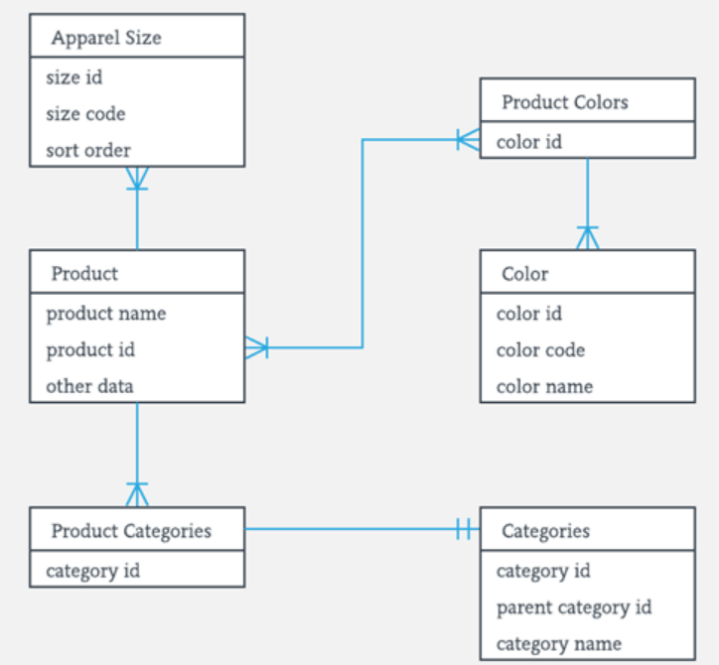

**Following are the main components and its symbols in ER Diagrams:**

**Rectangles**: This Entity Relationship Diagram symbol represents entity types

**Ellipses**: Symbol represent attributes

**Diamonds**: This symbol represents relationship types

Lines: It links attributes to entity types and entity types with other relationship types

Primary key: attributes are underlined

Double Ellipses: Represent multi-valued attributes

**ENTITY**

Conceptually it’s a table in Database that stores data in column.

**Attributes**

Column name in table.

**Cardinality**

Cardinality represents the relationship ( One-to-One, One-to-Many, Many-to-Many) between two table.

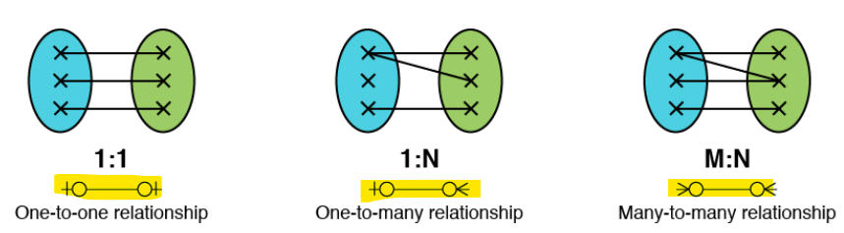

**Crow foot notation**

Crow foot notation is one of the approaches to represent the cardinality of relationship in an ER Model. It has four symbol to represent it.

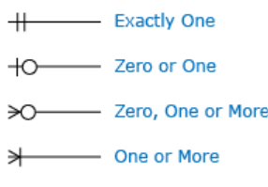

Example: Let take the below notation-

|  |  |
| --- | --- |
|  | From this notation we can identify that a computer can be allocated to exactly one employee but an employee can be allocated with zero or any number of computers |